

**CSE4001-INTERNET AND WEB PROGRAMMING**

**Name : ANAND RAJ**

**Registration No : 20BCE10062**

**School : computer science and engineering**

**Slot No : C11+F11**

**Semester : Winter- Inter Semester-1**

SCREENSHOT OF THE WEB PAGE

* Header





* Audio+Footer



CODE (HTML+BOOTSTRAP) SCREENSHOT

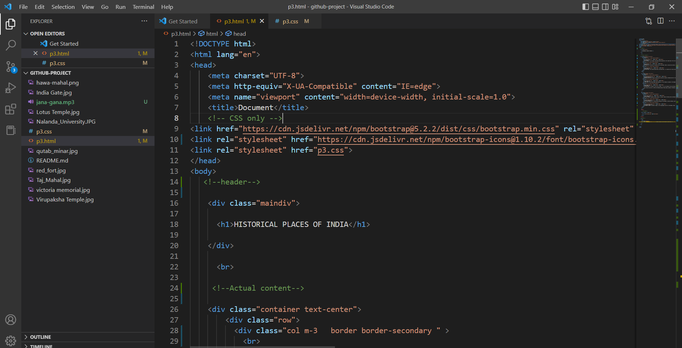

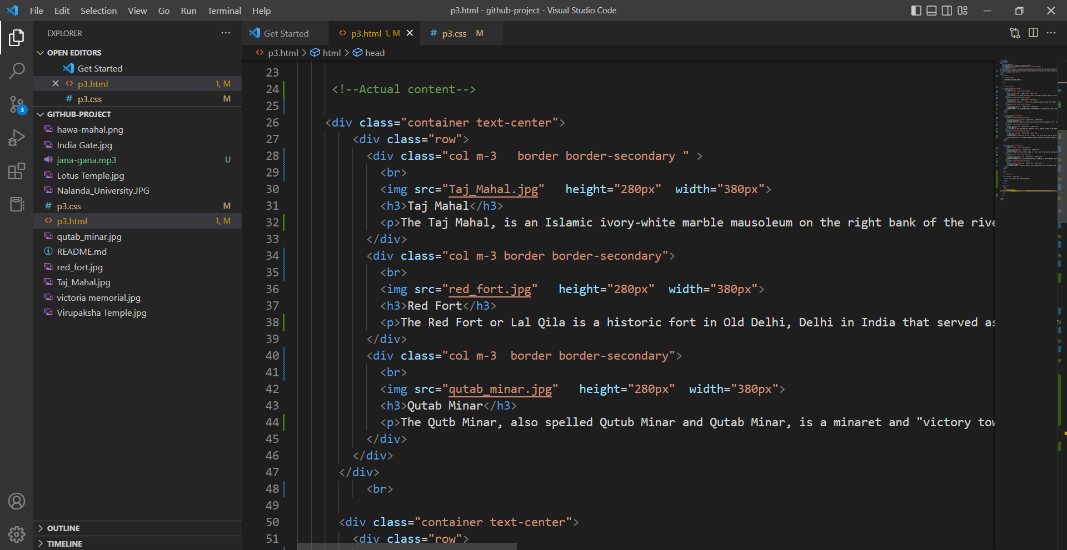

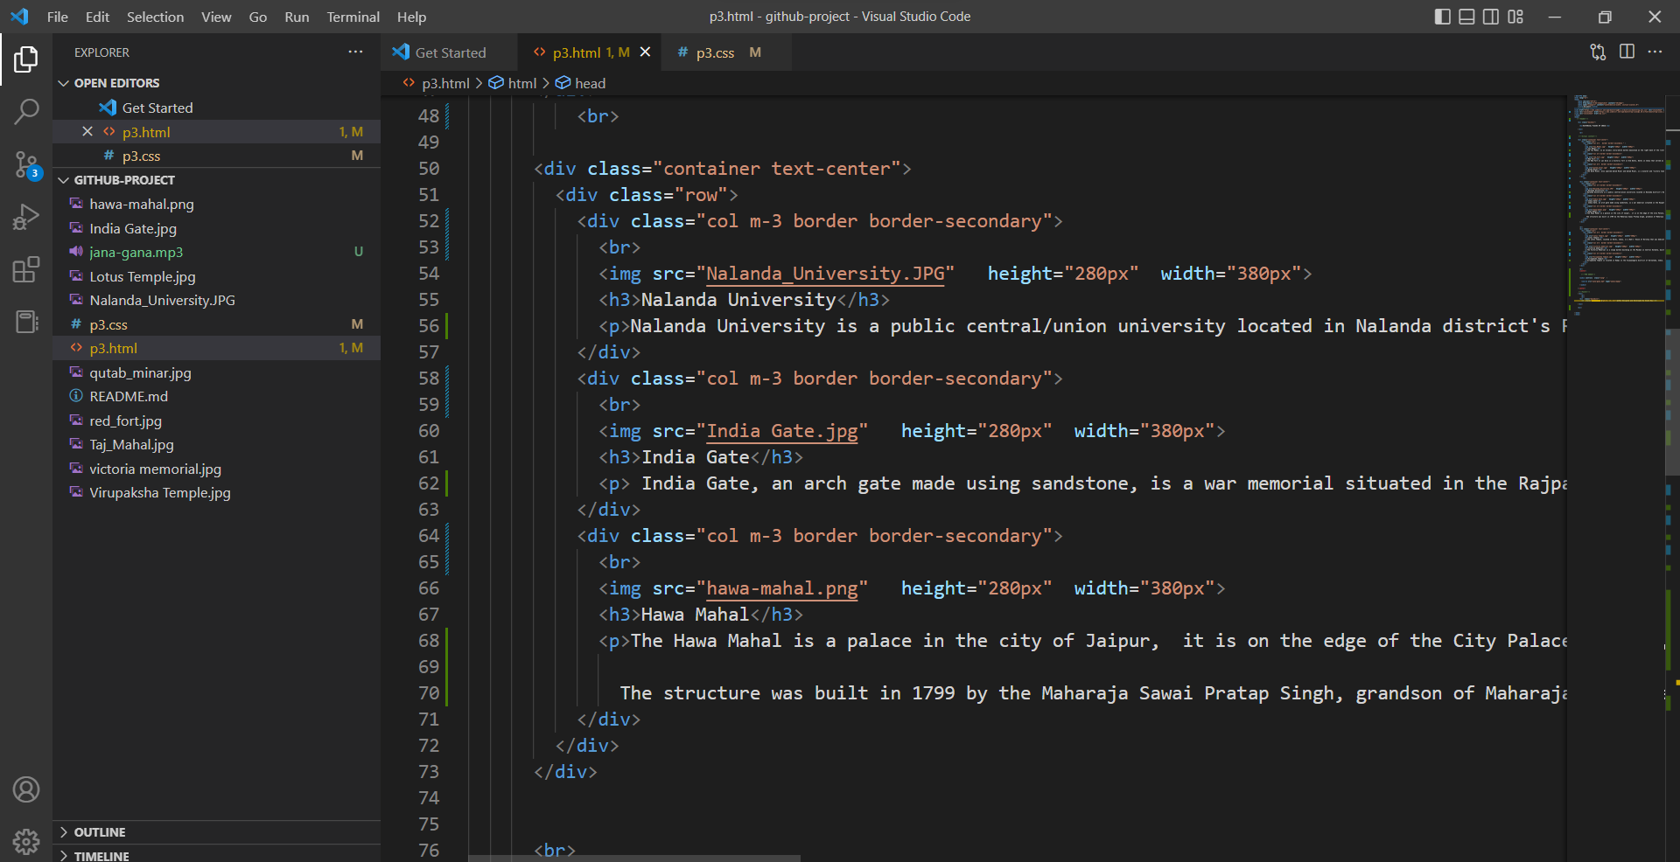

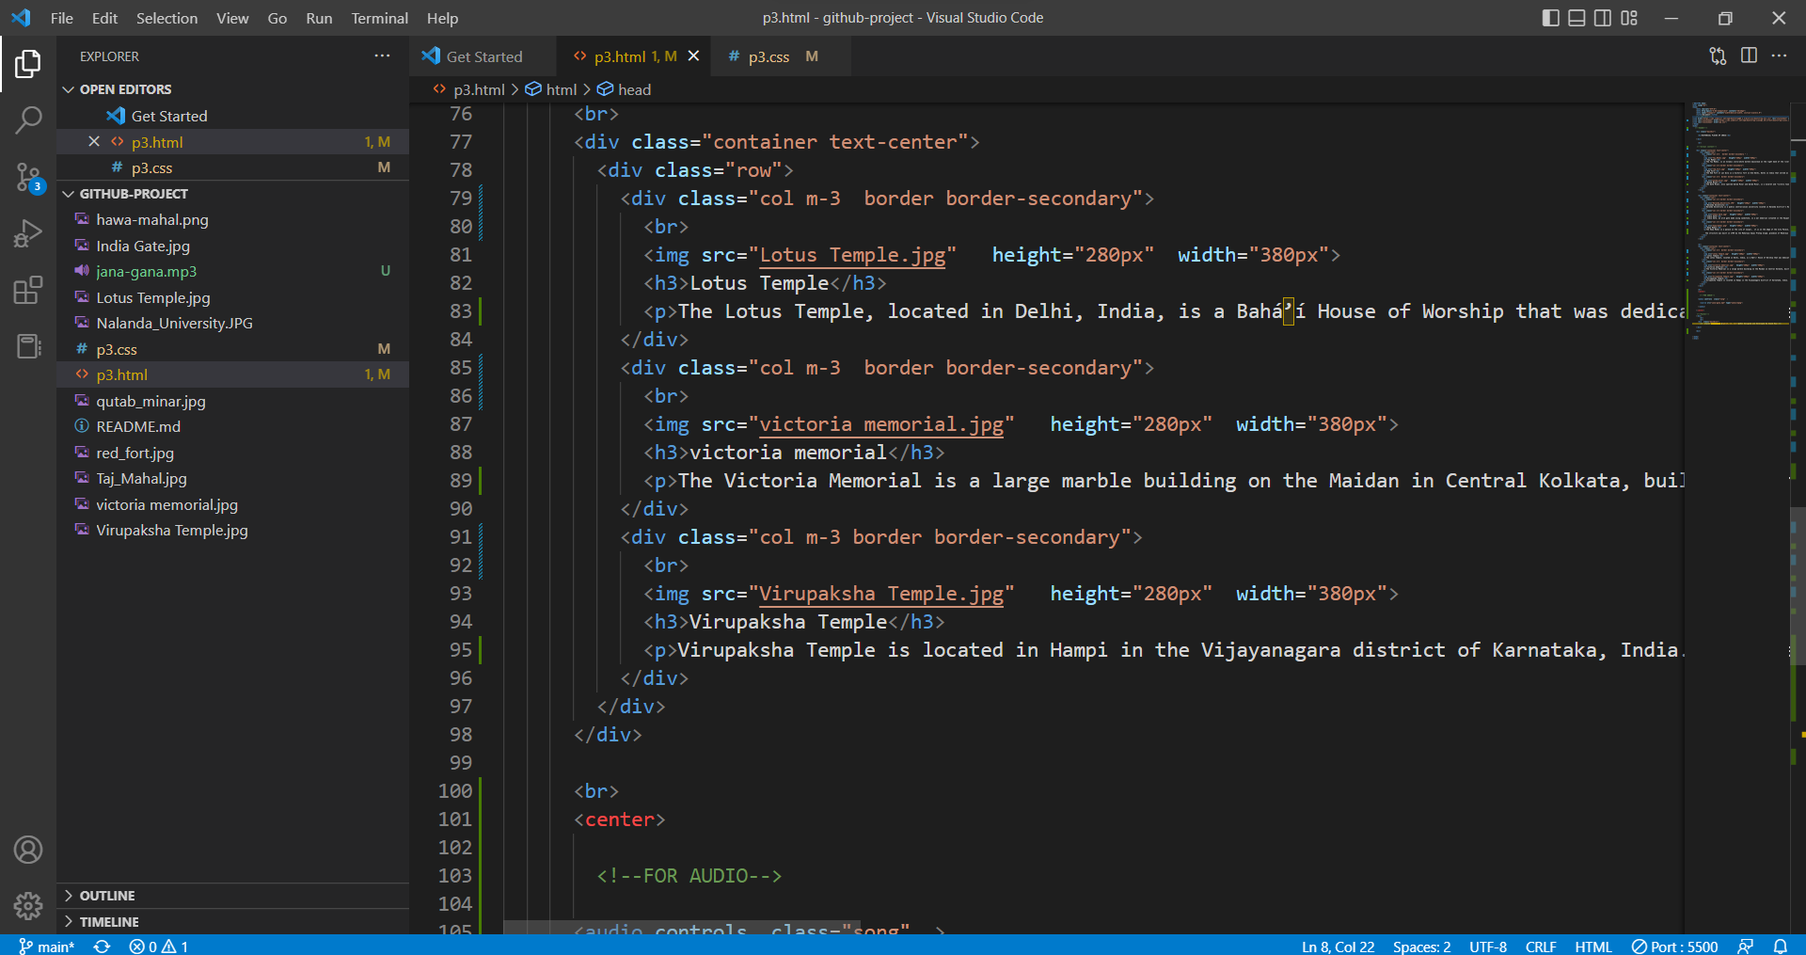

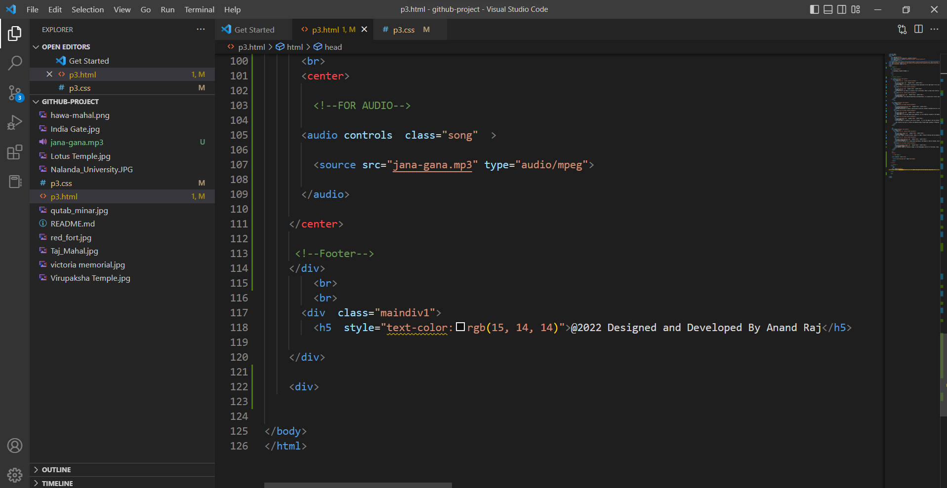

CODE(CSS)

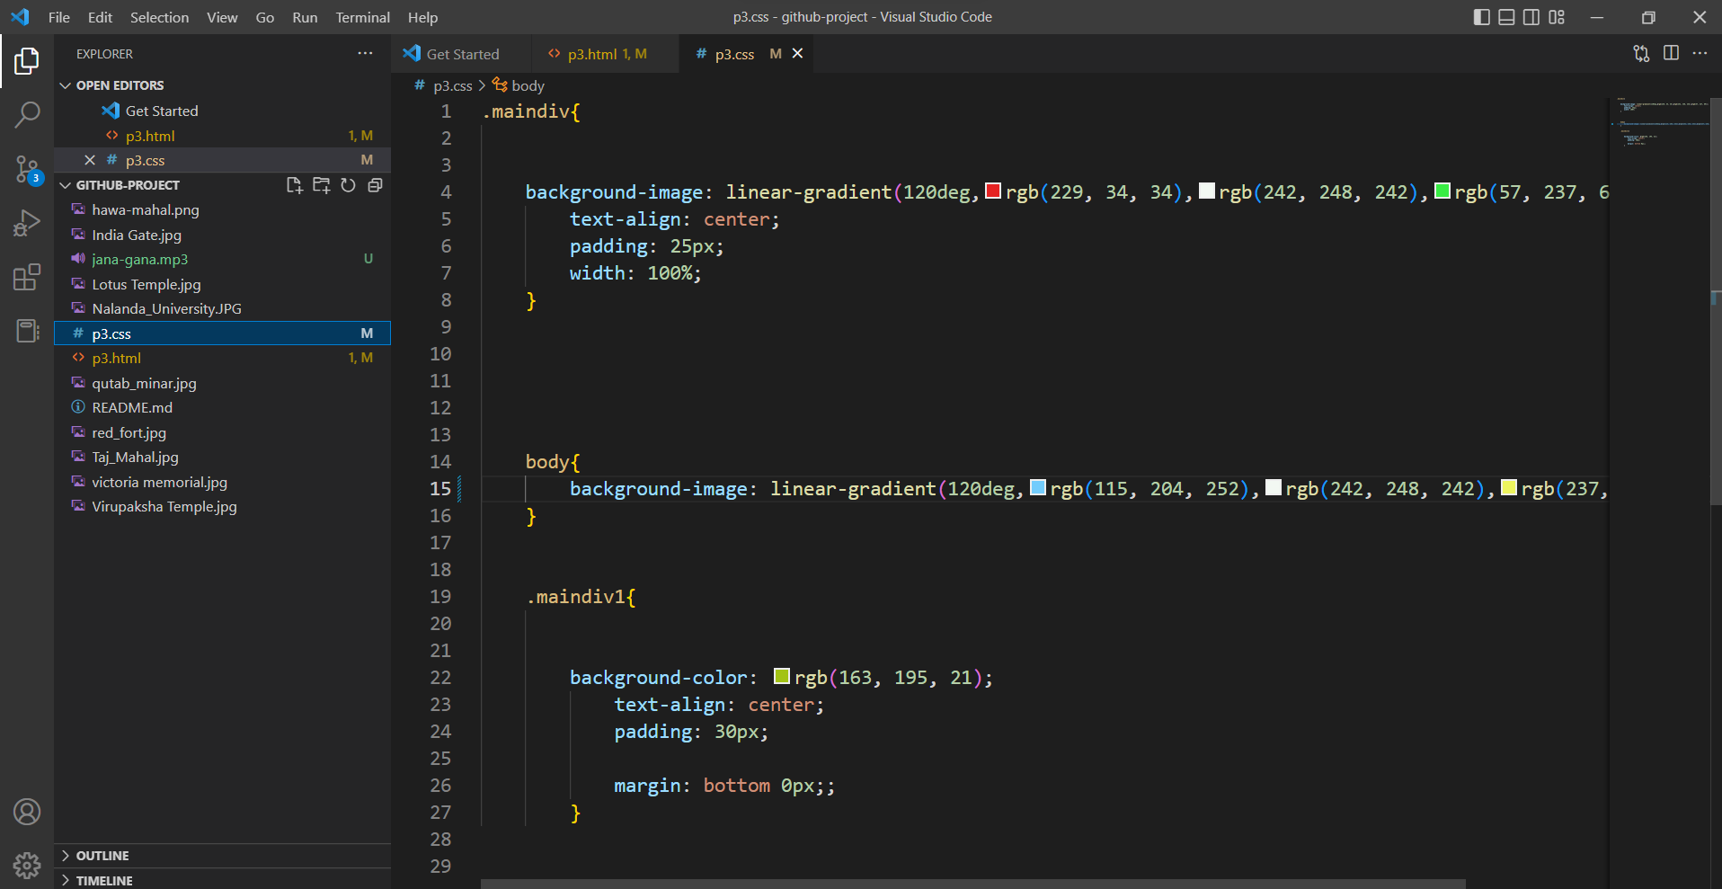

****************************************************

**THANK YOU**